 

**PRACTICUM JOURNAL**

AY 2022-2023

Zeki Yul G. Oralde

BSIT – Web Development

CoreDev Solutions Inc.

INTERNSHIP PROGRAM

DESCRIPTION

This course is intended to let the students gain relevant experience in a real work environment, provide them opportunity to apply the skills, knowledge and attitude they learned in the classroom and develop proper work attitude. It will help them enhance their awareness of the challenges in the IT industry and likewise contribute to company’s labor workforce.*

The internship program aims to provide students with training exposure and work experience in the following areas:

1. Software Development

2. Quality Assurance

3. Technical Support

4. Research

At the end of the internship period, students are expected to develop the following intended learning outcomes:

• Knowledge for Solving Computing Problems

• Problem Analysis

• Design/Development of Solutions • Modern Tool Usage

• Individual and Team Work

• Communication

• Computing Professionalism and Ethics in the Society

• Life-Long Learning

Internship is a requirement for the BSCS, BSIT and BSIS programs. Students are eligible to enroll in the internship program after completing 70% of the total number of units in the curriculum. The minimum number of internship hours for BSIT and BSIS is 500 hours and 300 hours for the BSCS program.

BACHELOR OF SCIENCE IN COMPUTER SCIENCE (BSCS)

The Computer Science program is the study of computing concepts and theories, algorithmic foundations and new developments in computing. (CHED MEMO 25 s2015)

The program prepares students to acquire skills and disciplines required for designing, writing and modifying software components, modules and applications that comprise software solutions.

SPECIALIZATION TRACK:

Data Analytics - Enables students to design and build intelligent software solutions that are designed to support better decision making process.

BACHELOR OF SCIENCE IN INFORMATION TECHNOLOGY (BSIT)

The Information Technology is the study of the utilization of hardware and software technologies involving planning, installing, customizing, operating, managing and administering, and maintaining information technology infrastructure. (CHED MEMO 25 s2015)

The program prepares students to meet the computer technology needs of business, government, healthcare, schools and other kinds of organization.

SPECIALIZATION TRACKS:

Web applications development - Equipped with the sufficient technical knowledge that enable students to design & develop cutting edge mobile applications.

Mobile applications development - Capable of using web technologies to design and develop aesthetically looking and functional web applications and web services

Multimedia applications development - Develop innovative and creative applications such as games and digital arts media which combines audio, video, graphics, sounds and animation.

BACHELOR OF SCIENCE IN INFORMATION SYSTEMS (BSIS)

The Information Systems program is the study of application and effect of information technology to organization. Graduates of the program understand the complex technological and organizational factors (that includes components, tools, techniques, strategies, methodologies, etc.) affecting the successful implementation of an information system. (CHED MEMO 25 s2015)

The program prepares students to help organizations determine how information and technology-enabled business processes can be used as strategic tool to achieve a competitive advantage.

IN-CAMPUS INTERSHIP

The in-campus internship is a program designed to provide students with software development experience in a simulated work environment.

An in-campus software development unit will be set up in the Research and Development Laboratory in Basak Campus which will serve as the venue for training. Teams are made up of undergraduate students and faculty members who expressed interest in working on projects of sponsoring companies.

A sponsoring company will be identified to provide the details/specifications for the projects to be worked on. They will also provide training to define job responsibilities of key persons involved.

The sponsoring company shall screen and select qualified students to participate in the training program. Application letter, resume and informative copy of the grades shall be submitted to the intern coordinator who then forwards the documents to the company representative for examination and/or interviews.

FIELD INTERNSHIP

The field internship is an immersion program intended to provide students with software development experience in an actual work environment.

Students are deployed in various IT companies in Cebu where they learn and acquire skills, knowledge and attitude relevant to their field of study.

PROCEDURES

1. An annual OJT Fair is organized prior to the start of semester when Practicum subject is enrolled. This aims to provide an avenue to help students get to know the different internship opportunities available and find the right company to work for during their internship. Invited companies present their company profile and what they can offer to further hone student capabilities through actual industry immersion.
2. INTERNSHIP ORIENTATION shall be conducted before the start of the practicum period to discuss on the concepts, objectives, policies and requirements of the internship program.
3. Students are encouraged to take the initiative in identifying companies/institutions/organizations who will accept them as trainees. Selection of companies should meet the criteria set by the college and approval is still subject to the approval of the Internship Coordinator. The internship coordinator will also release list of companies providing slots for internship.
4. The student should notify the internship coordinator the soonest if they are unable to find a qualified company for internship. The latter will try to match the students with partner-institutions, on a best-effort basis, depending on the availability of slots.
5. Student shall submit to the internship coordinator REGISTRARS SUBJECT EVALUATION as proof of completion of the pre-requisite subjects.
6. The LETTER OF ENDORSEMENT will be used in applying for internship which is available in template form and can be downloaded from the course website. Once accepted, the student shall return a copy of the endorsement letter duly signed by the accepting company.
7. A weekly activity report will be required from the students to account their activities and learning. Students should write their journal regularly which includes accomplishments for the week and realization about the tasks. Standard format for the internship journal should be in paragraph form so as to develop further the students’ writing skills.
8. Students will be required to submit pictures in uniform within the workplace with the presence of the immediate superior and co-employees as documentation of the internship program.
9. Performance appraisal shall be submitted by the immediate superior at the end practicum period.
10. Terminal report shall be submitted as final requirement to summarize the whole internship experience which includes but not limited to:

a. process of finding the practicum placement

b. working in the organization/company

c. work schedule

d. most memorable practicum moment

e. difficulties encountered and solutions made

COURSE REQUIREMENTS

The students are required to complete the internship hour requirements, obtain a satisfactory rating from the immediate superior and the internship coordinator, and attend the school-prescribed internship activities to pass the course. The rating instrument shall be developed by the internship coordinator and will be the instrument used by the supervisor in assessing the performance of the intern for purposes of course grading.

The school-prescribed practicum activities which students are required to attend are as follows:

Pre-internship Orientation, where the instructions, guidelines and requirements of the internship program will be given by the internship coordinator.

Monthly Meeting, where internship coordinator ask for feedback related to intern’s work environment, duties and responsibilities, and other work-related concerns. Attendance to monthly meetings is required.

Post-internship Presentation where the interns share insights, realizations and other relevant experiences they acquired during the internship period.

The Grade of the Students will be computed based on the following:

* Terminal Report/Journal – 30%
* Performance Evaluation – 30%
* Job Points (Hrs * Nature of Work) – 30%
* Post-internship Presentation – 10%

100%

PRACTICUM POLICY

1. The intern shall report to the office on time from Monday to Friday. The intern shall serve on the date and time specified in the endorsement letter.

2. The intern should report to the office even if classes are suspended or during examination period unless it is a public holiday. He/she is only allowed to be absent with valid reasons.

3. The intern should inform the office before or on the day of his/her absence. An excuse letter duly acknowledged by the immediate superior as EXCUSED shall be attached to the daily time record (DTR).

4. The weekly activity report, which outlines the tasks accomplished by the intern, must be accomplished and countersigned by the immediate supervisor.

5. The intern is subject for termination for recurring UNEXCUSED absences without prior notice (AWOL) or a written complaint from the company is raised due to misbehavior. All work hours rendered shall be forfeited.

6. An unexcused absence incurred more than 10 working days within the internship period is equivalent to a grade of 5.0.

7. Required school activities, Christmas vacation, PUJ strikes and natural calamities will not be considered as absent, provided the office is informed in writing duly signed by the internship coordinator.

8. The intern is not allowed to use cell phone or to receive personal calls unless it is an emergency. The intern is not allowed to read novels, magazines or study lessons during office hours.

9. The intern is not allowed to make any loans or credits either in cash or in kind from the offices she or he is assigned.

10.The intern should wear the prescribed internship uniform and school ID for the entire duration of the period. If there is no notice for not wearing the uniform and a written complaint is raised by the company, disciplinary actions shall be imposed.

11.Overtime (beyond 6PM) or extension of internship period may be arranged between the intern and the office concerned and would, therefore, be beyond the jurisdiction of the school.

12.The intern should not expect to receive any remuneration or pay after their internship period.

13.A training plan should be defined by the company which states the intern’s work assignment, the duration of the training, immediate supervisor and the skills that the student will develop at the end of the internship period.

14.The company shall designate an internship supervisor to ensure that the students learn according to the training plan.

15.A Memorandum of Agreement (MOA) should be signed prior to the start of the internship to formalize partnership of the company, the university and the student trainees.

I, ________________________, HEREBY UNDERSTOOD AND AGREED TO THE POLICY SET FOR THE INTERNSHIP PROGRAM FOR THE YEAR __________.

CONFORME:

____________________

signature over printed name STUDENT

_____________________

signature over printed name PARENT(S)/GUARDIAN

____________________

signature over printed name APPROVAL OFFICER

NOTED BY:

MR. RODERICK BANDALAN

Chairperson, CS/IT Dept.

DR. JOVELYN C. CUIZON

Dean, CICCT

Personal Information

Name: Zeki Yul G. Oralde_________________________

Address: Tubod Minglanilla Cebu___________________

Mobile No: 0919908974_____________________________

Email address: gersalinazeki@gmail.com___________

Course: Bachelor of Science in Information Technology

Specialization: __Web Development_________________

Employment Details

Company Name: _CoreDev Solutions Inc______________________

Address: ___J. Alcantara St, Cebu City__________________________

Contact person: Ms. Catherine H. Salgados

Telephone No: (032) - 328-2694 GLOBE | (032) - 234-5954 PLDT

Email address: infor@coredev.ph

Job Description

Job Title: Web Developer

Location: J. Alcantara St, Cebu City/ Work from Home

Terms: Intern Student

Salary/Rate: none

Requirements: own devices

About the Role: A web developer makes and maintains websites. They are in charge of a site's overall look and feel. Web developers also handle the technical aspects of a website, including its performance (website speed) and capacity (the maximum amount of traffic the site could handle at a given time).

Company Profile

CoreDev is a Premier Software Solutions provider in the Philippines

Services:

Software Development:

are not just into core accounting and banking software solutions, we also have other software products that will suit your needs.

Hardware Distributor:

also sell computer peripherals, servers, printers (passbook, pos printer and etc.).

[Service Provider](https://coredev.ph/):

provide 24/7 technical support to our valued clients. Our helpdesk is always open to your concerns and inquiries. Feel free to contact us any time of the day. We are at your service.

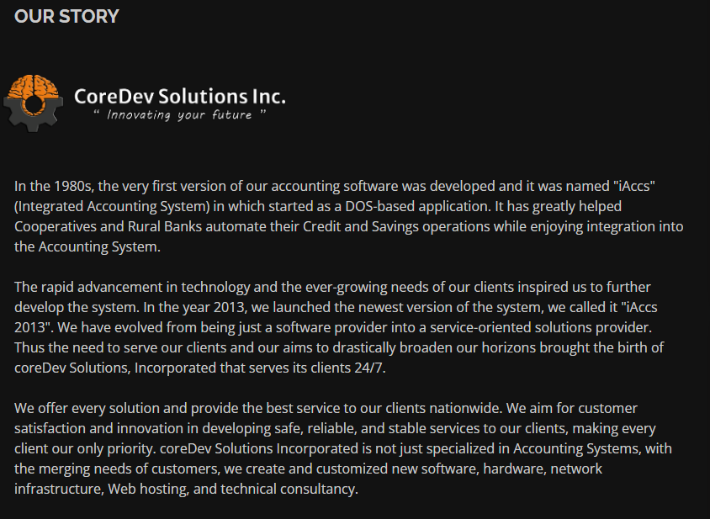

Date of Evaluation: 05/05/2023

Rating

|  |  |  |
| --- | --- | --- |
| 1. **Quality of work** |  |  |
| Ability to work with thoroughness, accuracy and neatness    2. **Quantity of Work** |  | 4 |
| Individual productivity, swift execution of tasks with least errors    3. **Dependability** |  | 4 |
| Ability to perform and complete work as instructed and when needed extends office hours when demanded.    4. **Cooperation** |  | 4 |
| Ability to work harmoniously with others, follow instructions carefully.    5. **Personality** |  | 4 |
| Effectiveness in control with others, courtesy, tact, dresses neatly and appropriately.    6. **Attendance** |  | 4 |
| Regular and punctual in office attendance, proper observance of break periods and dismissal time.    7. **Resourcefulness** |  | 3 |
| Ability to develop innovative solutions and adjust readily to changing circumstances    8. **Managerial Potentials** |  | 5 |
| Can deal with people effectively, handle problems correctly and manage other resources efficiently. |  | 3 |
|  | **TOTAL:** | **31** |

**Comments:**

**Self-disciplined, creative and resourceful, has the ability to finish the tasks given within the timeframe and has the skills needed for web development. So far so good!**

|  |  |
| --- | --- |
|  | Rated by: Sir Clyde Ortega 05-05-2023  Name of Supervisor/Employee and Date  (Signature over Printed Name) |

EVALUATION OF PRACTICUM EXPERIENCE BY STUDENT

Name of Supervisor __Sir Clyde Ortega_______

Date of Evaluation __05-05-2023_____________

Supervisor __Sir Clyde Ortega_______

Please rate and comment on the practicum experience on the following areas by indicating the rating which most represents your evaluation

RATING

5 - Excellent 4 - Very Good 3 - Good 2 - Fair 1 - Poor

|  |  |  |
| --- | --- | --- |
|  | Rating | Comments |
| Immediate Superior | 5 | The company has a very approachable superior that will help you in everything that you need |
| Co-workers | 5 | The co-workers are very fun and accommodating. Always find time to help you in need your needs |
| Workplace | 4 | The place is not what you expect, but gets your job done. |
| Opportunities to learn new skills | 5 | The company has broadened my skills in becoming a software developer and helped in different kinds of ways. |
| Tasks assigned | 5 | The task that was assigned to me was a helpdesk in which was has many complicated systems but was able to work on it. |
| Overall experience | 5 | Overall, it was a very wonderful experience |

What were the greatest benefits you received from this internship?

It has honed me to honed my skills and test myself If I am capable in the industry ______________________________________________________________________________ ______________________________________________________________________________

What were the biggest problems you encountered in this internship?

One of the biggest encounters was time because I was not able to fully understand the whole system. It’s like we were rush deployed, hence was not really to understand all of it

What suggestions do you have for improving the practicum program?

Nothing, it is a wonderful experience

Do you recommend this company to future practicum students?

Yes

FINAL INSIGHTS

Write an essay detailing your whole practicum experience.

The Practicum is a very wonderful experience, since you can really see what the like to be working in the industry. It is so overwhelming, because we are expected to handle a project and those projects are very big and tied with clients so one wrong move could jeopardize the system, so I realize how you should be careful in dealing with it. You can also experience the culture of the company, you can meet every kind of person and also you can also meet bad experiences, but all in all it was a unique and important experience for me because it has let me experience how competitive the industry that I will be working in the future.

MY INTERNSHIP PICTURES

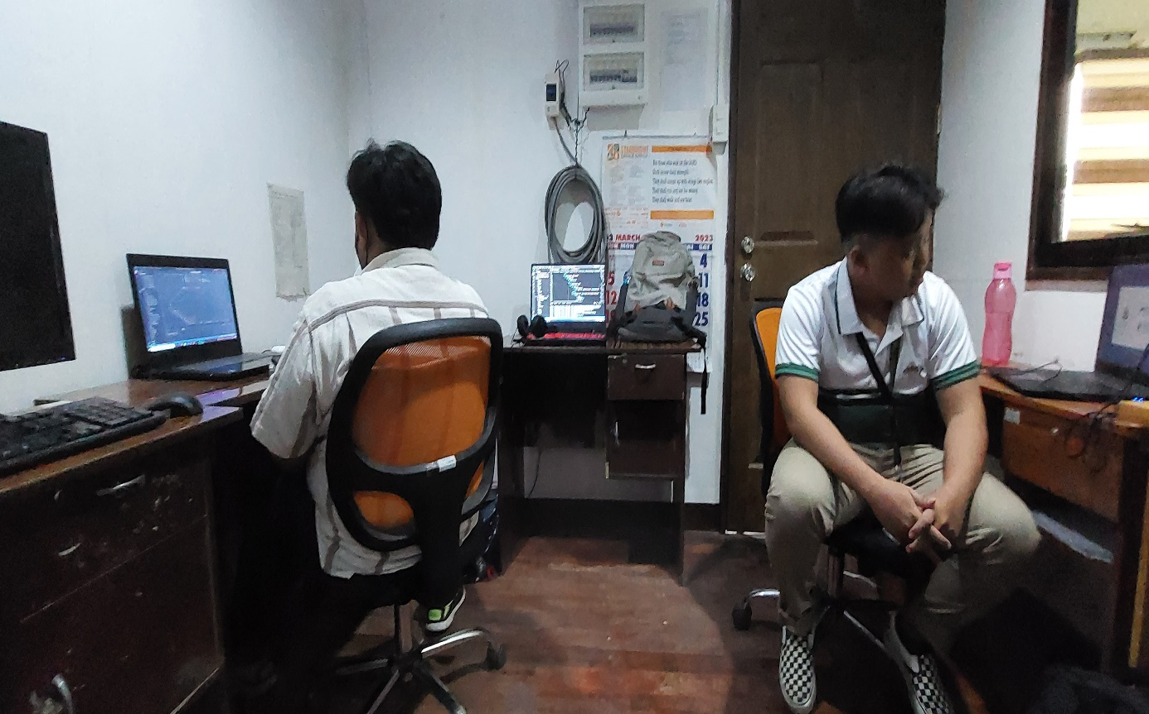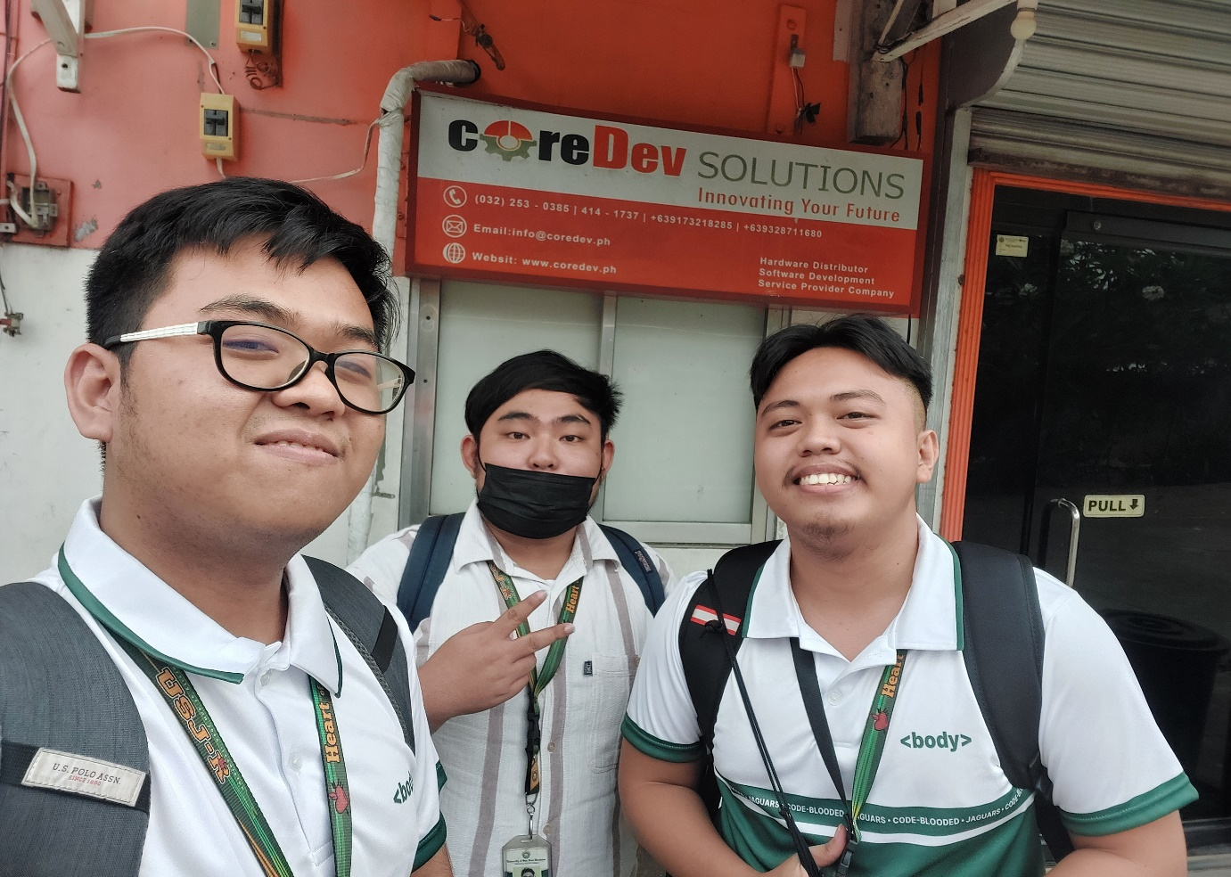(1) with visible company logo (2) with co-workers (3) with supervisor (4) while at work